3.2 OneLake Catalog & Real-Time Hub

Key points
OneLake Catalog (previously known as the OneLake Data Hub):
- The OneLake Catalog exists to help you discover, manage, and use data from across your organisation.

- You can explore data in your organisation, by Domain, by Workspace, by Sensitivity Label.

- Importantly, if you give item-level access to someone, the only place they can go to access that item is through the OneLake data hub (because they won't have Workspace access!).
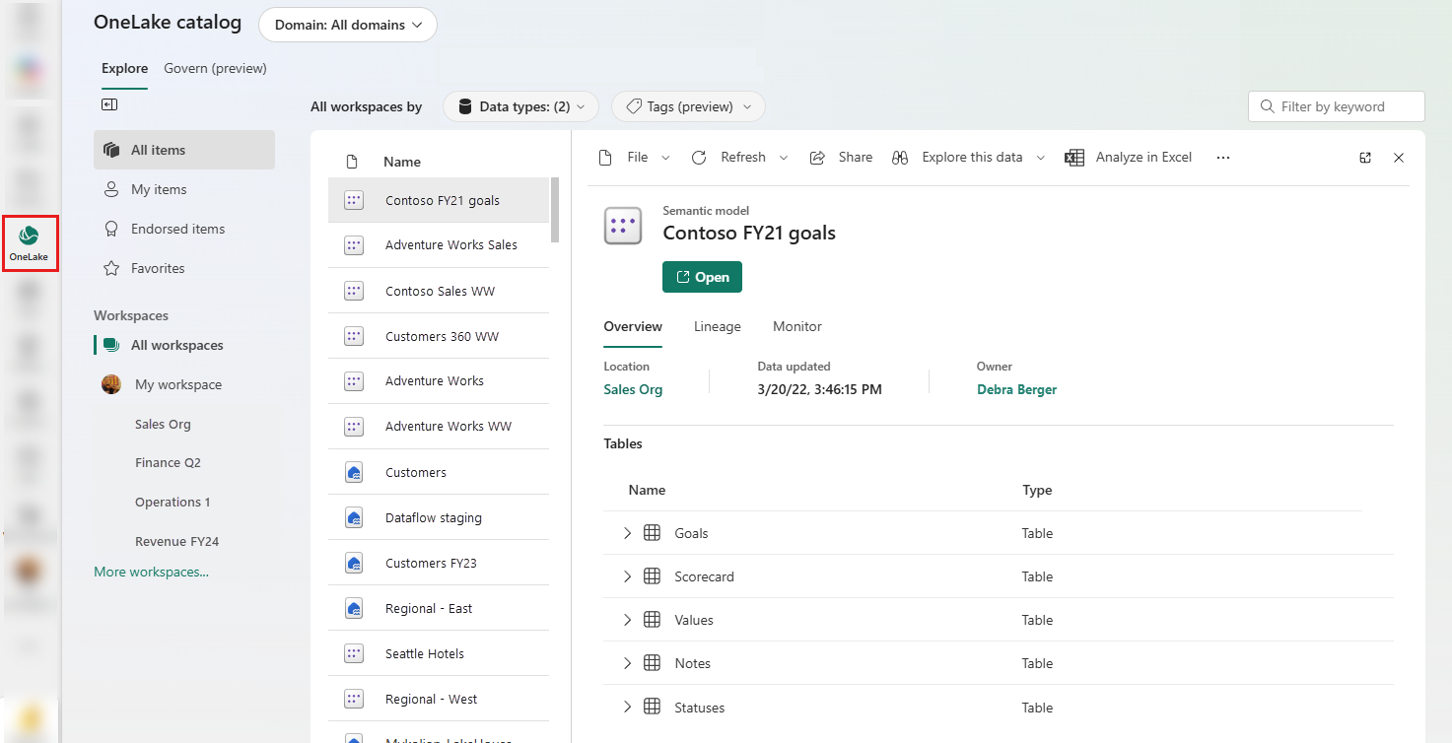

Real-time hub:
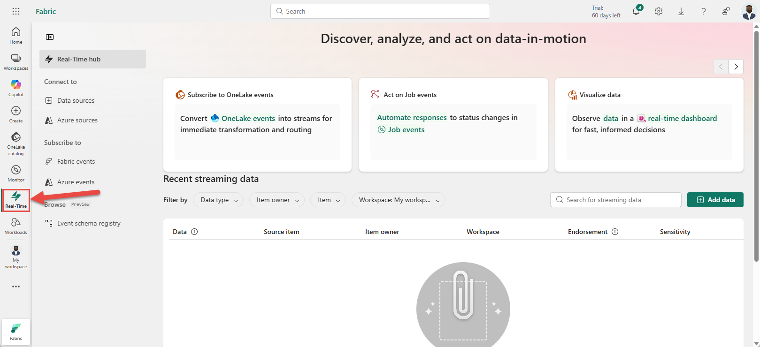
- Similarly, the real-time hub performs the same function, but focuses on streaming data. It lists all the streams and Kusto Query Language (KQL) tables that you can act directly on. It also gives you an easy way to ingest streaming data from Microsoft products and Fabric events.

